**Question no 1**

**Write a recursive function that takes a number as input and check whether the number is**

**prime or not.**

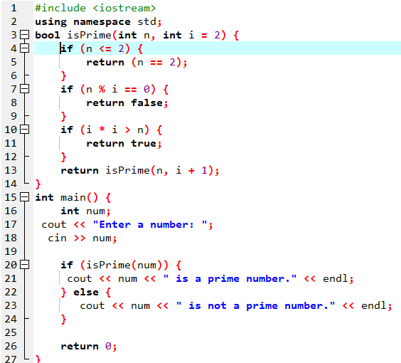

OUTPUT:

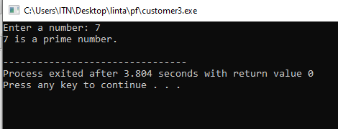

**Question no 2**

**Create a function that uses three arrays pens, books and pencils to store the number of**

**items purchased by customer. The program inputs the number of pens, books and pencils**

**to be purchased by customer and stores them in corresponding arrays. The program**

**finally displays the total bill of each customer according to the following prices:**

**10 Marks**

**Rs. 5 @ pen**

**Rs. 100@books**

**Rs. 10 @ pencil**

**The output should appear as follows:**

**----------------------------------------------------------------------------------------------------------------**

**Customer No. Pens Books Pencils Total bill**

**----------------------------------------------------------------------------------------------------------------**

**1 5 100 10 Rs. 115**

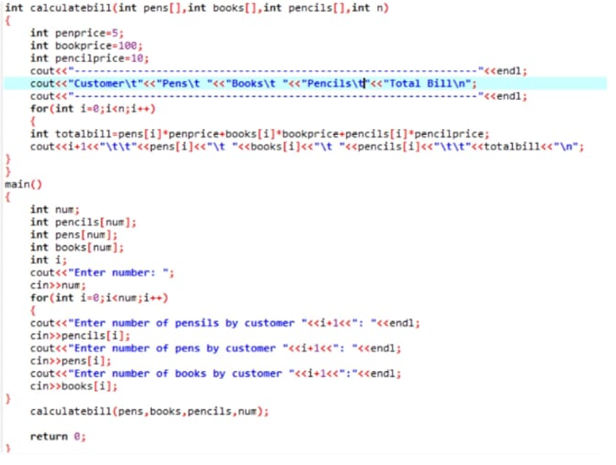

Output

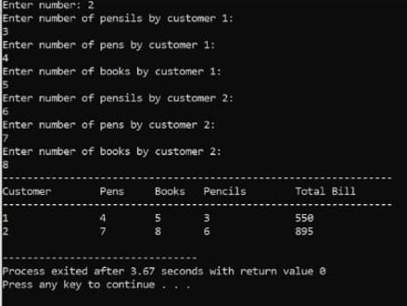

**Question no 3**

**Write a program that store 10 integer values in an array and compute the sum of the**

**elements of an array.**

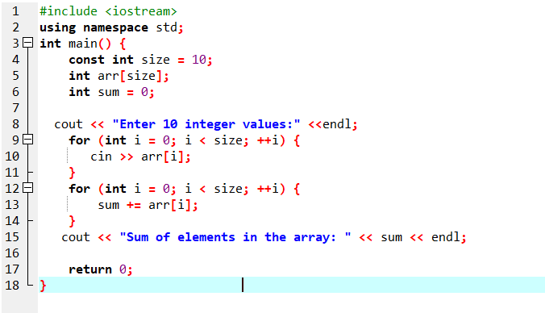

Output

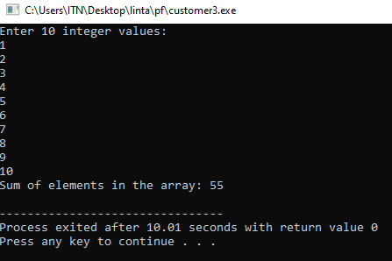

**Question no 4**

**Write a function that displays a solid rectangle of asterisks whose height is specified in**

**integer parameter height. For example, if the height is 4, the function display the**

**following:**

**\*\*\*\***

**\*\*\*\***

**\*\*\*\***

**\*\*\*\***

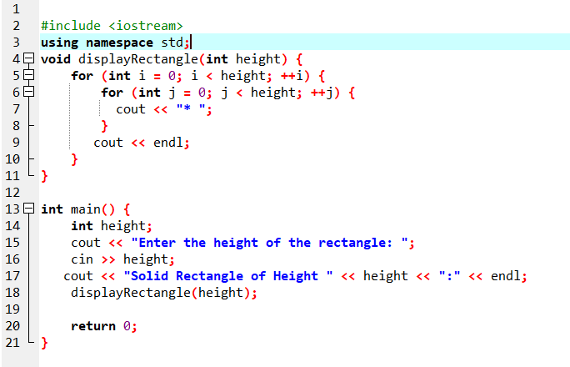

Output

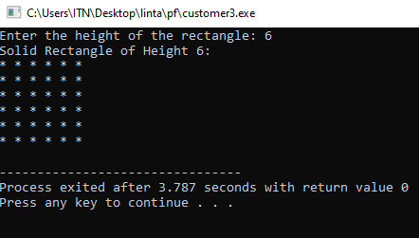

**Question no 5**

**Write a program that lets the user enter 10 values into an array. The program should then**

**display the largest and smallest values stored in the array.**

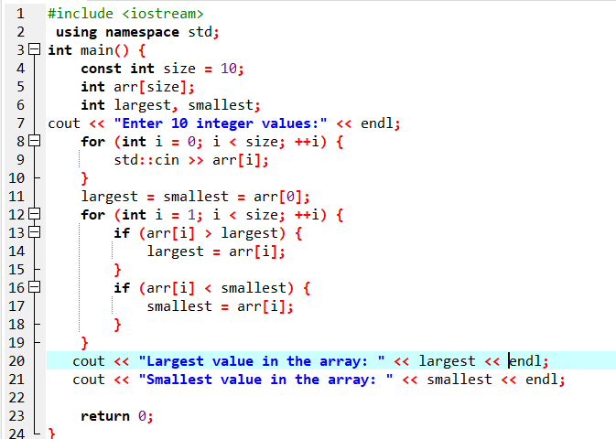

**output**

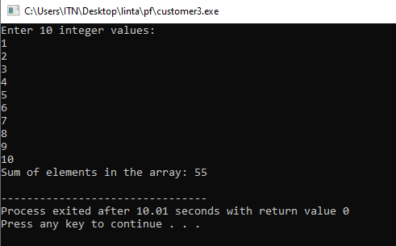

**Question no 6**

**Write a program that lets the user enter the total rainfall for each of 12 months into an**

**array of doubles. The program should calculate and display the total rainfall for the year,**

**the average monthly rainfall, and the months with the highest and lowest amounts.**

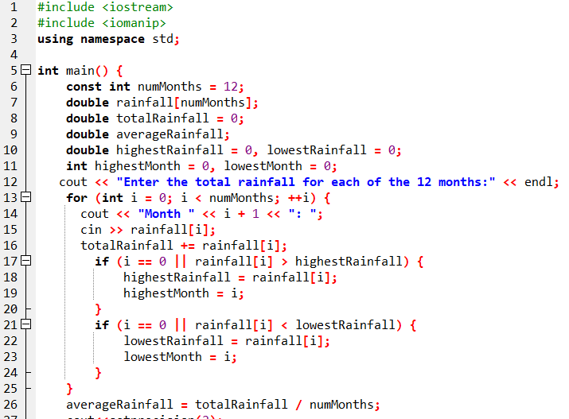

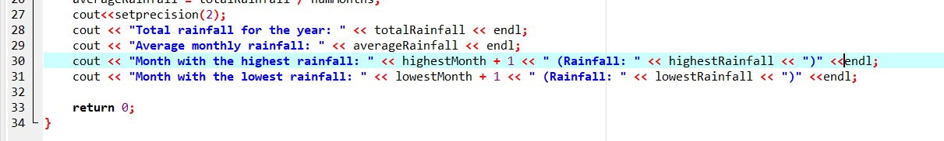

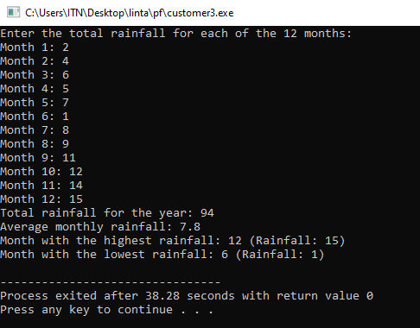**OUTPUT**